KRG RETAILS ANALYSIS
Dashboard-1
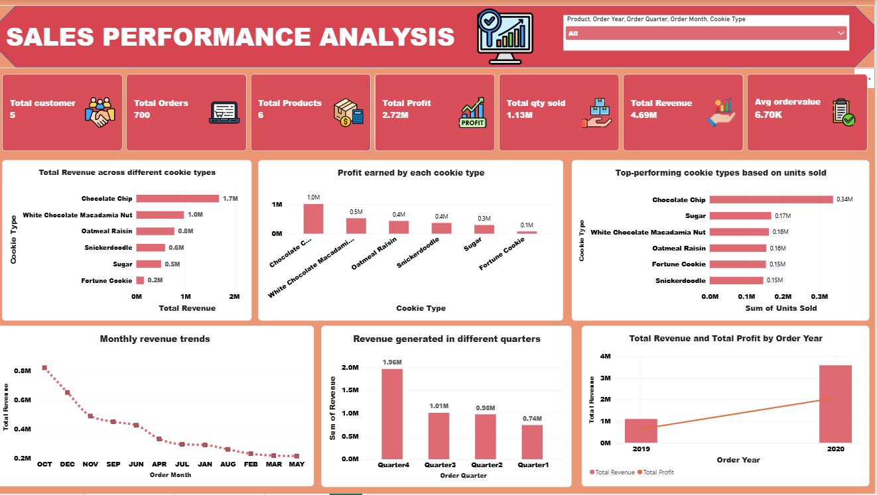

Dashboard-2


